**Lab 6 Pre-lab Report:**

**Part 1.2:**

­ 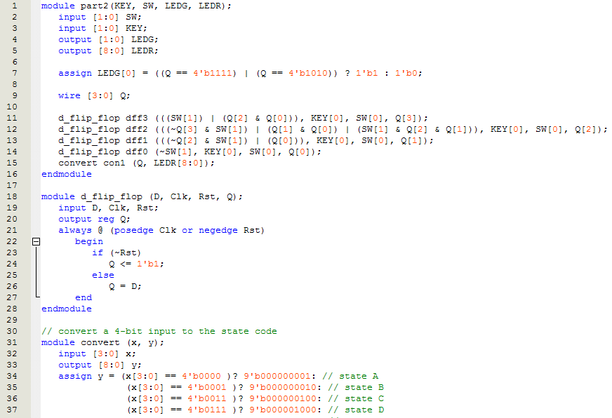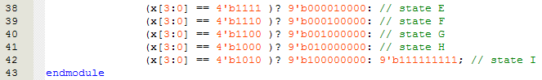

**Part 1.3:**

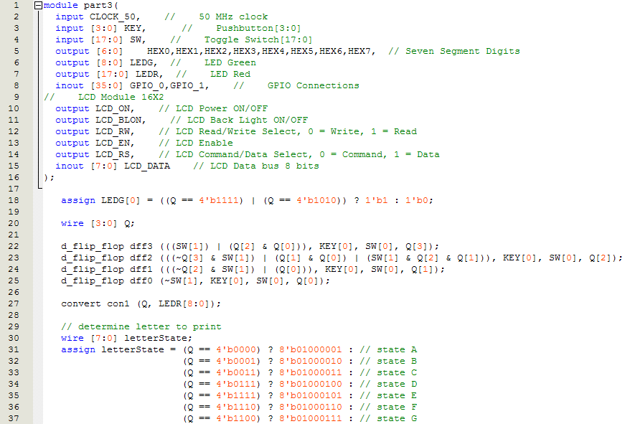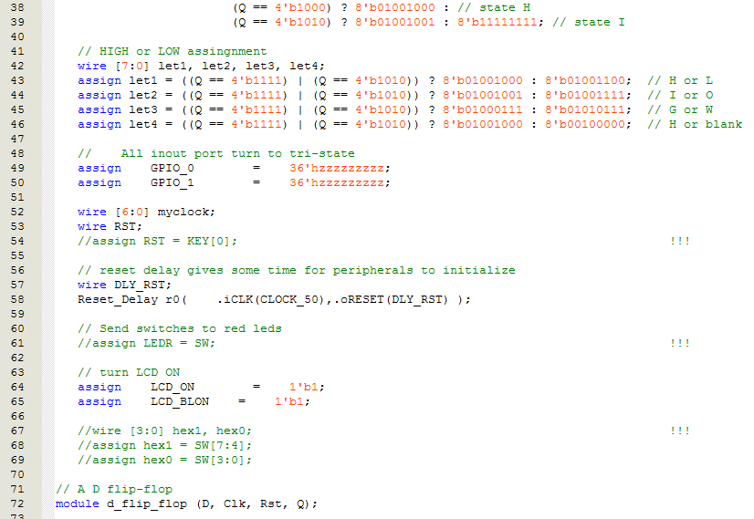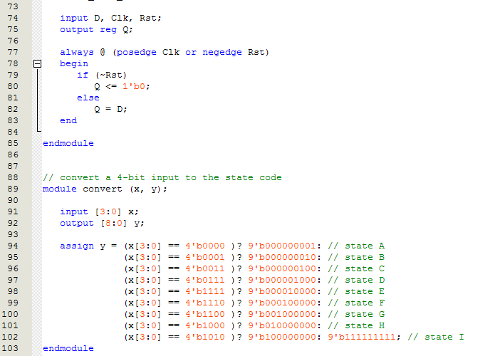

**Part 1.4:**

**Part 1.5:**

**Part 1.6:**